**WALPOLE PRIMARY SCHOOL**

Nature | Culture | Future

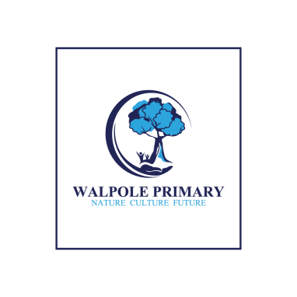

**WOW Cruise**

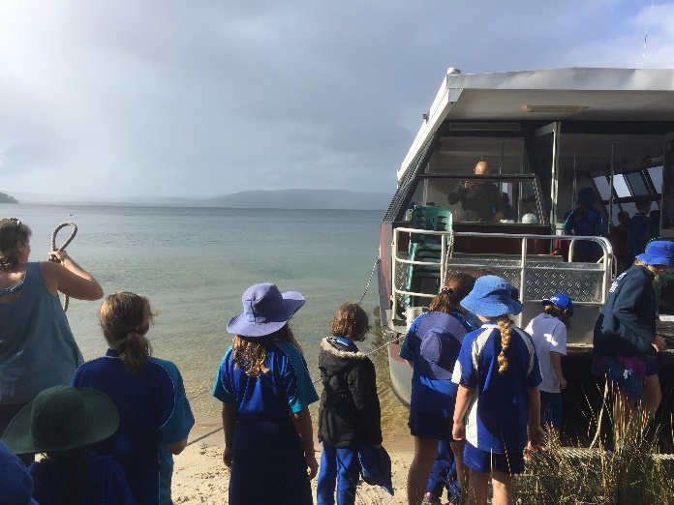Generally in term two, as part of our URWalpole program, the students have an afternoon or two out on Gary Muir’s boat. The students study the topic selected and get to discover it firsthand. They also take part in the rehabilitation of sand dunes near Shelley Beach.

Usually, the students meet the boat about 12:30pm. They wash their feet at the Boot Cleaning Station and learn about the spread of Dieback and other diseases.

Then all aboard on an adventure! Gary entertains them with stories linked to the URWalpole theme. He exposes them to scientific terms and research.

At times, there are scientists or special guests onboard. They share their knowledge of our theme as we cruise over to Shelley or Circus Beach. Then we scour the dunes to discover more about the topic.

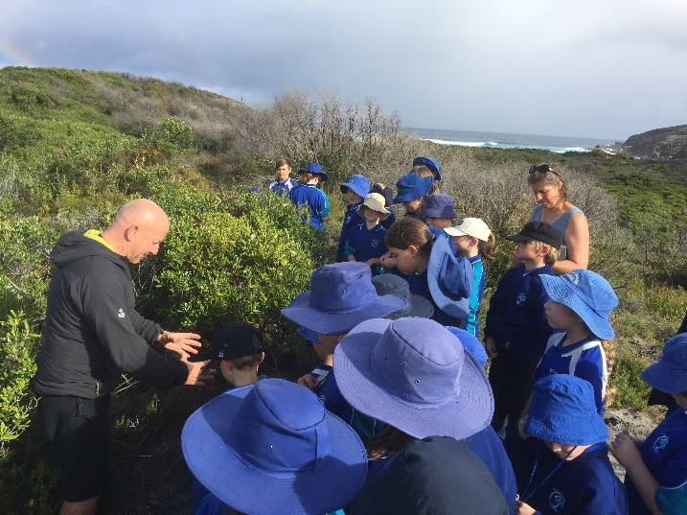When we rehabilitate the dunes, staff from Parks and Wildlife talk about the collection of endemic plants and the reason for rehabilitation. They show the students how to dig a deep whole for the plant so it can survive over summer.

We always have time for Gary’s special Tingle Cake and cordial before we set off on our way back to school.