**WALPOLE PRIMARY SCHOOL**

Nature | Culture | Future



**Interschool Cross Country**

The Interschool Cross Country is held at East Manjimup Primary School, mid-term two. Year 3-6 students from as far as Katanning compete against each other on a track on and near the school grounds.

There are up to four competitors per age group and gender, e.g. yr 4 boys and yr 4 girls from each school. Walpole PS send their most competitive students to participate.

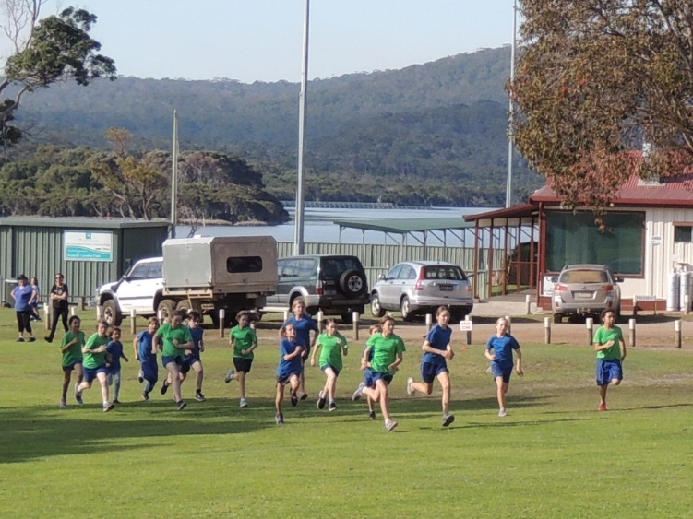We leave school at 8:30am and head up on the bus to Manjimup. It takes about an hour and a half. Children who get motion-sickness are encouraged to sit at the front of the bus.

When we arrive, the students walk the track so they know where to run. It can change from year to year. The Year 3/4 students run 1600m and the Yr 5/6 students run 2200m. The event is still held when it rains but not in windy conditions as there is the danger of falling branches.

The races start about 11am, going from youngest to oldest. The finish line is on the oval so we all get to see the runners complete the race. Presentations are around 12:30.

Normally two helpers from each school are required to stand on the track to make sure the runners are safe and going in the right direction.

Students wear their school uniform and running shoes. They need to pack a hat, drink, towel, lunch and morning tea. The canteen may be operating and children can preorder lunch.

After the presentations, we hop back on the bus and head home. We arrive by 3pm to enable bus children to catch transport home.