**WALPOLE PRIMARY SCHOOL**

Nature | Culture | Future



**Faction Athletics Carnival**

In term one, Walpole Primary have their Faction Athletics Carnival. It’s a full day of track and field events, with opportunities for the parents to be involved.

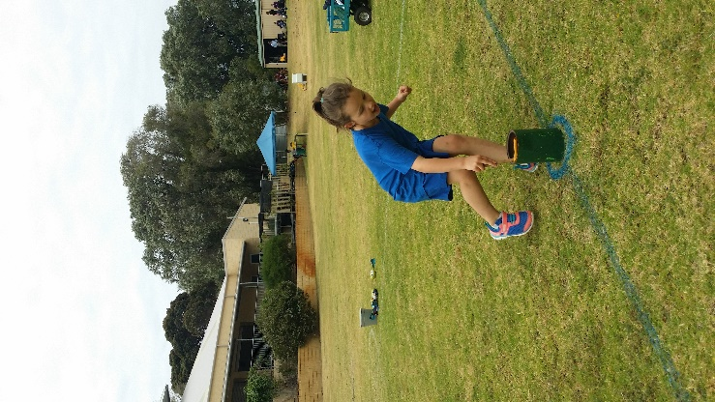We normally have over 90% of the parents turn up and bring along their friends and family members. Bring a chair, rug and a picnic to make a day of it. The P&C usually have a sausage sizzle and have tea and coffee available.

All of the K-6 students participate in a number of individual and team events throughout the day. If the Yr 1-6 students gain a place in a race, they earn a ribbon and points for their faction. K/P races are all about participation. Intermediate (Yr 3/4) and Senior (Yr 5/6) students are also in the running for Championship and Runner-up trophies.

Events are organized into K/P, 1/2, 3/4 and 5/6 groupings. Genders are mixed as we found they have very little impact on times or distances.

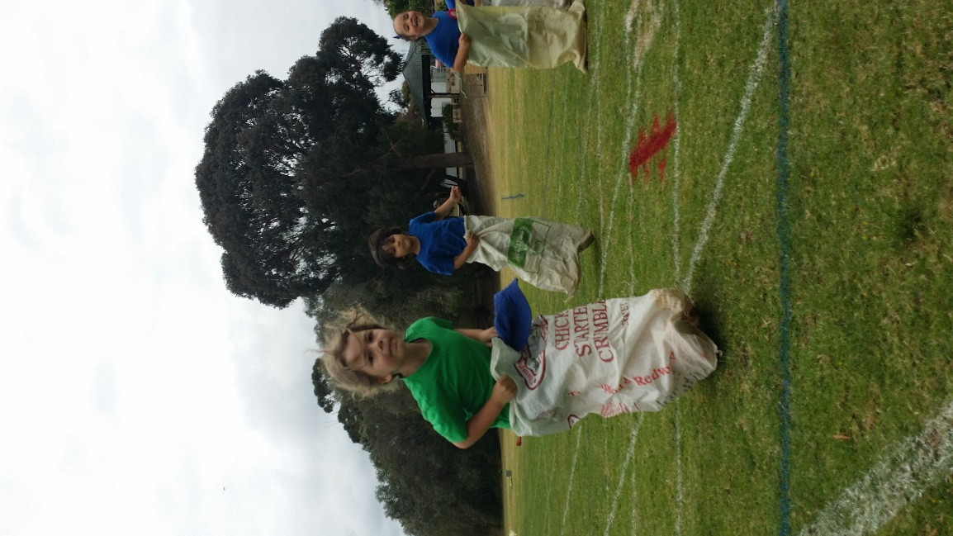Year 1-6 students start the day with jumps and throws. Long jump for all and triple jump for the 3-6 students. They also throw a ‘chook’ or a shot put.

Year 3-6 students are also invited to run the 800m. This race does not go towards championship points but first and second place win a medallion.

After morning tea, the K/Ps join the others. That’s when the real fun starts. We have short distance races, bean bag, flag, leaderball, tunnelball, passball, wheelball, thread the needle and egg and spoon races. Some of these also cater for parent teams. The last events to score faction points are the relays. Students always look forward to the final fun event, the tog o war.

By 3pm, it is all over. Champions are identified and the winning faction gets a perpetual trophy.